Vocabulary – Bio/Chem 1 Unit 3

Word | Definition | Image
Atom | smallest piece that an element can be divided into; very tiny! | 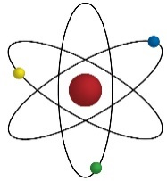
Bond | something that binds or holds together | 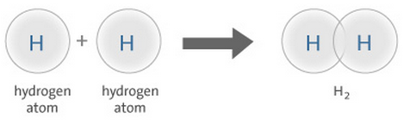
Configuration | arrangement | 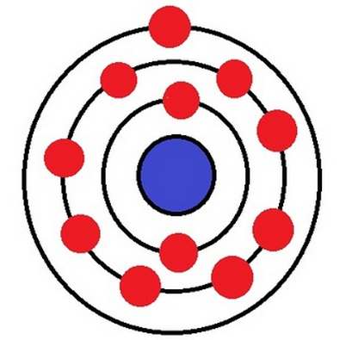
Core | on the inside; core electrons are closest to the center of the atom | 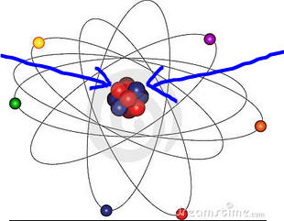
Electron | part of an atom; has a negative charge | 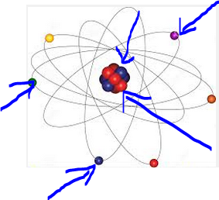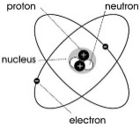
Electro-negativity | how strongly an element attracts electrons; fluorine is very electronegative | 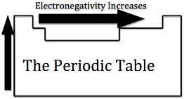
Element | a kind of matter that makes up everything on earth; examples – carbon, oxygen, iron, silver
Energy | power to do work
Ion | atom that has unequal numbers of protons and electrons; has a positive or negative charge | 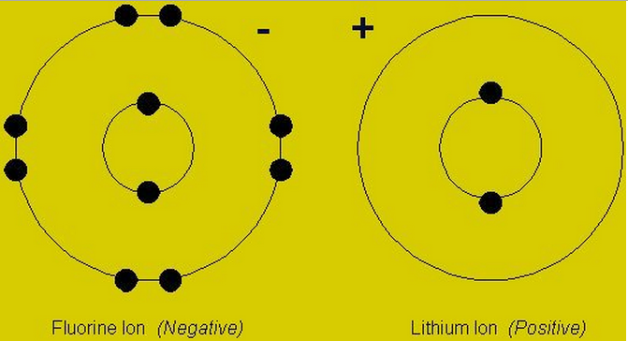
Molecule | more than one atom bonded together | 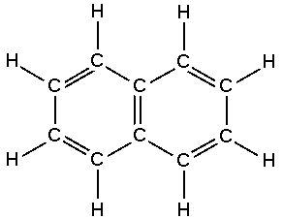
Neutron | part of an atom in the nucleus; has no charge (neutral) | 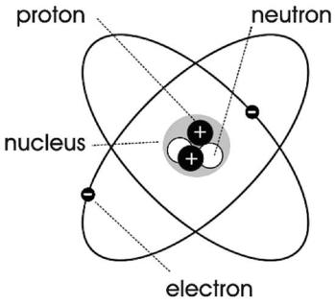
Nucleus | center of the atom; protons and neutrons located here
Periodic Table | chart that organizes the elements; elements are in order of how many protons they have  - period – row on the periodic table (across)  - group – column in the periodic table (down) | 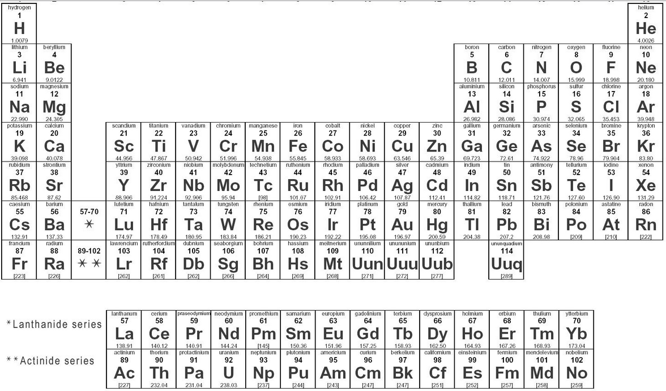
Proton | positively charged part of an atom; found in the nucleus
Shell | “ring” around the center of an atom; electrons located here | 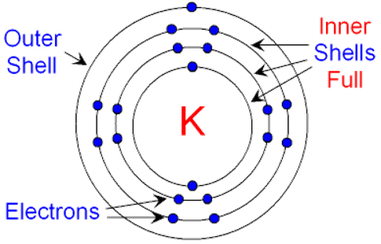
Shielding | protection; an element with more shells outside its nucleus is more “shielded” | 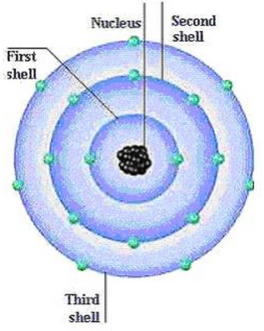
Valence | on the outer edge; valence electrons are in the outside shell (farthest from nucleus) | 