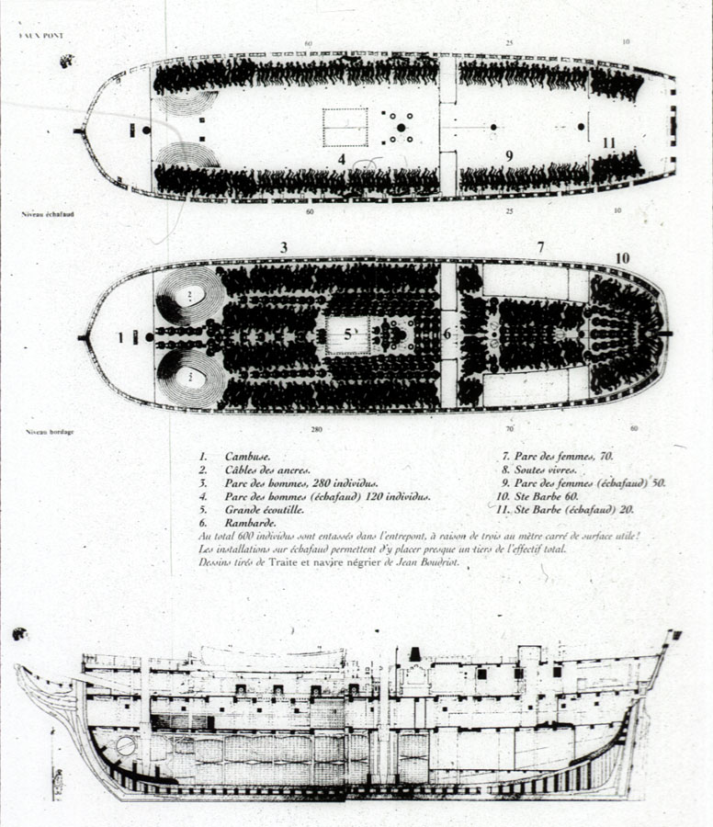
Comments
Artist's reconstruction of decks aboard the Aurore, which sailed from La Rochelle in 1784, picked up about 500 Africans from north of the Congo River, and sold its captives in Saint Domingue. The illustration shows tight packing of captives and storage areas. This illustration was apparently produced expressly for the exhibition in Nantes, and was done by Jean Boudriot; it is a composite of two of his earlier drawings which were first published in his Traite et Navire Negrier lAurore (Paris: published by author, 1984), pp. 38-39, 46-47. David Moore helped in the identification of this source.
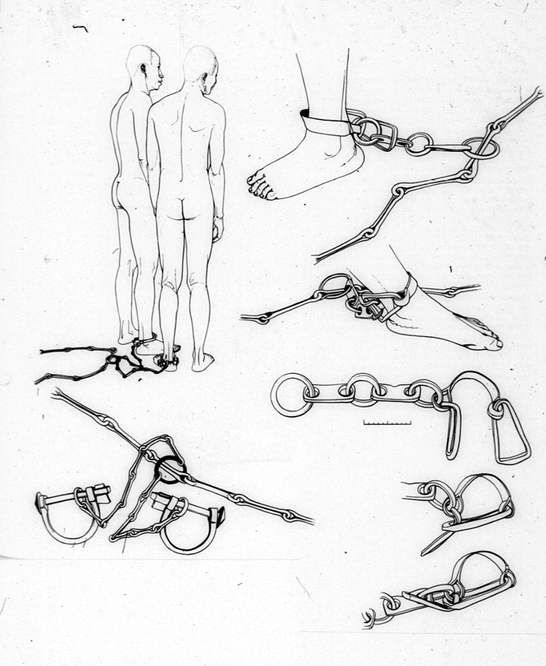
Source
Jean Boudriot, Traite et Navire Negrier l'Aurore, 1784 (Paris: published by author,1984), p. 83.
Comments
Line drawings showing placement of leg shackles; drawn from originals in French museums.

From: The Interesting Narrative of the Life of Olaudah Equiano, or Gustavus Vassa, The African
Chapter 2
I was trained up from my earliest years in the art of war: my daily exercise was shooting and throwing javelins, and my mother adorned me with emblems, after the manner of our greatest warriors. In this way I grew up till I had turned the age of eleven, when an end was put to my happiness in the following manner: Generally, when the grown people in the neighborhood were gone far in the fields to labor, the children assembled together in some of the neighboring premises to play; and commonly some of us used to get up a tree to look out for any assailant, or kidnapper, that might come upon us -- for they sometimes took those opportunities of our parents' absence, to attack and carry off as many as they could seize. One day as I was watching at the top of a tree in our yard, I saw one of those people come into the yard of our next neighbor but one, to kidnap, there being many stout young people in it. Immediately on this I gave the alarm of the rogue, and he was surrounded by the stoutest of them, who entangled him with cords, so that he could not escape, till some of the grown people came and secured him. But, alas! ere long it was my fate to be thus attacked, and to be carried off, when none of the grown people were nigh.
One day, when all our people were gone out to their works as usual, and only I and my dear sister were left to mind the house, two men and a woman got over our walls, and in a moment seized us both, and, without giving us time to cry out, or make resistance, they stopped our mouths, and ran off with us into the nearest wood. Here they tied our hands, and continued to carry us as far as they could, till night came on, when we reached a small house, where the robbers halted for refreshment, and spent the night. We were then unbound, but were unable to take any food; and, being quite overpowered by fatigue and grief, our only relief was some sleep, which allayed our misfortune for a short time. The next morning we left the house, and continued travelling all the day. For a long time we had kept the woods, but at last we came into a road which I believed I knew. I had now some hopes of being delivered; for we had advanced but a little way before I discovered some people at a distance, on which I began to cry out for their assistance; but my cries had no other effect than to make them tie me faster and stop my mouth, and then they put me into a large sack. They also stopped my sister's mouth, and tied her hands; and in this manner we proceeded till we were out of sight of these people. When we went to rest the following night, they offered us some victuals, but we refused it; and the only comfort we had was in being in one another's arms all that night, and bathing each other with our tears. But alas! we were soon deprived of even the small comfort of weeping together.
The next day proved a day of greater sorrow than I had yet experienced; for my sister and I were then separated, while we lay clasped in each other's arms. It was in vain that we besought them not to part us; she was tom from me, and immediately carried away, while I was left in a state of distraction not to be described. I cried and grieved continually; and for several days did not eat anything but what they forced into my mouth. At length, after many days' travelling, during which I had often changed masters, I got into the hands of a chieftain, in a very pleasant country. This man had two wives and some children, and they all used me extremely well, and did all they could do to comfort me; particularly the first wife, who was something like my mother. Although I was a great many days' journey from my father's house, yet these people spoke exactly the same language with us. This first master of mine, as I may call him, was a smith, and my principal employment was working his bellows, which were the same kind as I had seen in my vicinity. They were in some respects not unlike the stoves here in gentlemen's kitchens, and were covered over with leather; and in the middle of that leather a stick was fixed, and a person stood up, and worked it in the same manner as is done to pump water out of a cask with a hand pump. I believe it was gold he worked, for it was of a lovely bright yellow color, and was worn by the women on their wrists and ankles.
I was there I suppose about a month, and they at last used to trust me some little distance from the house. This liberty I used in embracing every opportunity to inquire the way to my own home; and I also sometimes, for the same purpose, went with the maidens, in the cool of the evenings, to bring pitchers of water from the springs for the use of the house. I had also remarked where the sun rose in the morning, and set in the evening, as I had travelled along; and I had observed that my father's house was towards the rising of the sun. I therefore determined to seize the first opportunity of making my escape, and to shape my course for that quarter; for I was quite oppressed and weighed down by grief after my mother and friends; and my love of liberty, ever great, was strengthened by the mortifying circumstance of not daring to eat with the free-born children, although I was mostly their companion.

Digital History ID 3807
Slavery Fact Sheets
Geography
1. Enslaved Africans came primarily from a region stretching from the Senegal River in northern Africa to Angola in the South.
2. Europeans divided this stretch of land into five coasts:
  - Upper Guinea Coast: The area delineated by the Senegal and Gambia Rivers
  - Ivory (or Kwa Kwa or Windward) Coast:Central Liberia
  - Lower Guinea Coast: Divided into the Gold Coast on the west (Cote d'Ivoire and Ghana), the Slave Coast (Togo, Benin, and western Nigeria), and the Bight of Benin (Nigeria and Cameroon)
  - Gabon
  - Angola
3. The Angolan coast supplied nearly half the slaves sent to the Americas.
Religion
1. Unlike European religions, most African religions were not based on sacred texts or scriptures, but rather on continuous revelation.
2. Most areas did not create a religious orthodoxy or have an entrenched priesthood.
3. Most African religions recognized a variety of supernatural beings.
4. Religious practice focused on contact between this world and the other world, typically through augury, divination, prophecy, and spirit mediumship.
Organization
1. The notion of tribes, combing a common language and customs with a political structure is mistaken. Atlantic Africa was divided into states (political units) and nations (cultural units).
2. While some states were quite large, others were quite modest in size and many were tiny, consisting of a capital town of a few thousand people and a dozen villages under its control.
3. In the 17th century, 70 percent of the people lived in states with fewer than 10,000 inhabitants.
4. Unlike the rich and powerful of Europe and Asia, those in Africa were not landowners, since African law did not recognize the right to own, sell, or rent land as property.
5. Private wealth usually derived from control of dependents--clients, pawns, wives in polygynous households, and slaves.
African Slavery
1. African law recognized slavery and the right of owners to alienate slaves.
2. A relatively low population density and an absence of the concept of property in land encouraged the development of slavery in West and Central Africa.
3. Slavery had been important in the medieval empires of Ghana, Mali, and Songhai, and slave exports had supplemented the export of gold.
4. Although African slavery was not a benign institution, slaves in Africa were used in a wider variety of ways than in the New World: they were employed as agricultural workers, soldiers, servants, and officials.
5. The great majority of slaves sold to Europeans were not slaves in Africa; they were usually recent war captives or victims of banditry and judicial proceedings.
6. Even under harsh chattel slavery, manumission was possible for a significant number of slaves and slaves usually had a right to keep any monetary earnings and buy their freedom.
7. Multi-generational slavery was uncommon; in part this reflected the fact that most African slaves were women.
8. During the early years of enslavement, African slaves usually worked under supervision. Then many became "allotment slaves," who worked five or six days until about 2 p.m. on the master's lands, and in the evenings and on their days off, worked their own plots. In the third stage settled slaves spent most of their time working their land in exchange for a fixed obligation, usually what it took to feed an adult male for a year.
Slave Trade
1. During the era of the Atlantic slave trade, many of those enslaved, perhaps a majority, were kept in Africa.
2. The Atlantic slave trade carried about two to three men for every woman.
3. The slave trade reduced the adult male population by about 20 percent, dramatically altering the ratio of working adults to dependents and of adult men to adult women.
4. One result of unbalanced sex ratios was to encourage polygyny.
5. Another result was to reduce traditional male forms of work, such as hunting, fishing, livestock rearing, the clearing of fields, the chopping down of trees, and the digging up of roots. The result was a less protein rich diet and a reduction in agricultural productivity.
6. About 14 percent of slaves sent to the New World were children under 14; 56 percent were male adults; and 30 percent were female adults.

Enslavement and the Slave Trade
Myth:New World slaves came exclusively from West Africa.
Fact: Half of all New World slaves came from central Africa.
Myth: Europeans physically enslaved Africans or hired mercenaries who captured people for export or that African rulers were "Holocaust abettors" who were themselves to blame for the slave trade.
Fact: Europeans did engage in some slave raiding; the majority of people who were transported to the Americas were enslaved by Africans in Africa.
Myth:Many slaves were captured with nets.
Fact: There is no evidence that slaves were captured with nets; war was the most important source of enslavement.

