Declaration of Pedro Naranjo of the Queres Nation. [Place of the Rio del Norte, December 19, 1681.]
In the said plaza de armas on the said day, month, and year, for the prosecution of the judicial proceedings of this case his lordship caused to appear before him an Indian prisoner named Pedro Naranjo, a native of the pueblo of San Felipe, of the Queres nation, who was captured in the advance and attack upon the pueblo of La Isleta. He makes himself understood very well in the Castilian language and speaks his mother tongue and the Tegua. He took the oath in due legal form in the name of God, our Lord, and a sign of the cross, under charge of which he promised to tell the truth concerning what he knows and as he might be questioned, and having understood the seriousness of the oath and so signified through the interpreters, he spoke as indicated by the contents of the autos.
Asked whether he knows the reason or motives which the Indians of this kingdom had for rebelling, forsaking the law of God and obedience to his Majesty, and committing such grave and atrocious crimes, and who were the leaders and principal movers, and by whom and how it was ordered; and why they burned the images, temples, crosses, rosaries, and things of divine worship, committing such atrocities as killing priests, Spaniards, women, and children, and the rest that he might know touching the question, he said that since the government of Señor General Hernando Ugarte y la Concha they have planned to rebel on various occasions through conspiracies of the Indian sorcerers, and that although in some pueblos the messages were accepted, in other parts they would not agree to it; and that it is true that during the government of the said senor general seven or eight Indians were hanged for this same cause, whereupon the unrest subsided. Some time thereafter they [the conspirators] sent from the pueblo of Los Taos through the pueblos of the custodia two deerskins with some pictures on them signifying conspiracy after their manner, in order to convoke the people to a new rebellion, and the said deerskins passed to the province of Moqui, where they refused to accept them. The pact which they had been forming ceased for the time being, but they always kept in their hearts the desire to carry it out, so as to live as they are living today. Finally, in the past years, at the summons of an Indian named Popé who is said to have communication with the devil, it happened that in an estufa of the pueblo of Los Taos there appeared to the said Popé three figures of Indians who never came out of the estufa. They gave the said Popé to understand that they were going underground to the lake of Copala. He saw these figures emit fire from all the extremities of their bodies, and that one of them was called Caudi, another Tilini, and the other Tleume; and these three beings spoke to the said Popé, who was in hiding from the secretary, Francisco Xavier, who wished to punish him as a sorcerer. They told him to make a cord of maguey fiber and tie some knots in it which would signify the number of days that they must wait before the rebellion. He said that the cord was passed through all the pueblos of the kingdom so that the ones which agreed to it [the rebellion] might untie one knot in sign of obedience, and by the other knots they would know the days which were lacking; and this was to be done on pain of death to those who refused to agree to it. As a sign of agreement and notice of having concurred in the treason and perfidy they were to send up smoke signals to that effect in each one of the pueblos singly. The said cord was taken from pueblo to pueblo by the swiftest youths under the penalty of death if they revealed the secret. Everything being thus arranged, two days before the time set for its execution, because his lordship had learned of it and had imprisoned two Indian accomplices from the pueblo of Tesuque, it was carried out prematurely that night, because it seemed to them that they were now discovered; and they killed religious, Spaniards, women, and children. This being done, it was proclaimed in all the pueblos that everyone in common should obey the commands of their father whom they did not know, which would be given through El Caydi or El Popé. This was heard by Alonso Catití, who came to the pueblo of this declarant to say that everyone must unite to go to the villa to kill the governor and the Spaniards who had remained with him, and that he who did not obey would, on their return, be beheaded; and in fear of this they agreed to it. Finally the senor governor and those who were with him escaped from the siege, and later this declarant saw that as soon as the Spaniards had left the kingdom an order came from the said Indian, Popé, in which he commanded all the Indians to break the lands and enlarge their cultivated fields, saying that now they were as they had been in ancient times, free from the labor they had performed for the religious and the Spaniards, who could not now be alive. He said that this is the legitimate cause and the reason they had for rebelling, because they had always desired to live as they had when they came out of the lake of Copala. Thus he replies to the question.
Asked for what reason they so blindly burned the images, temples, crosses, and other things of divine worship, he stated that the said Indian, Popé, came down in person, and with him El Saca and El Chato from the pueblo of Los Taos, and other captains and leaders and many people who were in his train, and he ordered in all the pueblos through which he passed that they instantly break up and burn the images of the holy Christ, the Virgin Mary and the other saints, the crosses, and everything pertaining to Christianity, and that they burn the temples, break up the bells, and separate from the wives whom God had given them in marriage and take those whom they desired. In order to take away their baptismal names, the water, and the holy oils, they were to plunge into the rivers and wash themselves with amole, which is a root native to the country, washing even their clothing, with the understanding that there would thus be taken from them the character of the holy sacraments. They did this, and also many other things which he does not recall, given to understand that this mandate had come from the Caydi and the other two who emitted fire from their extremities in the said estufa of Taos, and that they thereby returned to the state of their antiquity, as when they came from the lake of Copala; that this was the better life and the one they desired, because the God of the Spaniards was worth nothing and theirs was very strong, the Spaniard’s God being rotten wood. These things were observed and obeyed by all except some who, moved by the zeal of Christians, opposed it, and such persons the said Popé caused to be killed immediately. He saw to it that they at once erected and rebuilt their houses of idolatry which they call estufas, and made very ugly masks in imitation of the devil in order to dance the dance of the cacina; and he said likewise that the devil had given them to understand that living thus in accordance with the law of their ancestors, they would harvest a great deal of maize, many beans, a great abundance of cotton, calabashes, and very large watermelons and cantaloupes; and that they could erect their houses and enjoy abundant health and leisure. As he has said, the people were very much pleased, living at their ease in this life of their antiquity, which was the chief cause of their falling into such laxity. Following what has already been stated, in order to terrorize them further and cause them to observe the diabolical commands, there came to them a pronouncement from the three demons already described, and from El Popé, to the effect that he who might still keep in his heart a regard for the priests, the governor, and the Spaniards would be known from his unclean face and clothes, and would be punished. And he stated that the said four persons stopped at nothing to have their commands obeyed. Thus he replies to the question.
Asked what arrangements and plans they had made for the contingency of the Spaniards' return, he said that what he knows concerning the question is that they were always saying they would have to fight to the death, for they do not wish to live in any other way than they are living at present; and the demons in the estufa of Taos had given them to understand that as soon as the Spaniards began to move toward this kingdom they would warn them so that they might unite, and none of them would be caught. He having been questioned further and repeatedly touching the case, he said that he has nothing more to say except that they should be always on the alert, because the said Indians were continually planning to follow the Spaniards and fight with them by night, in order to drive off the horses and catch them afoot, although they might have to follow them for many leagues. What he has said is the truth, and what happened, on the word of a Christian who confesses his guilt. He said that he has come to the pueblos through fear to lead in idolatrous dances, in which he greatly fears in his heart that he may have offended God, and that now having been absolved and returned to the fold of the church, he has spoken the truth in everything he has been asked. His declaration being read to him, he affirmed and ratified all of it. He declared himself to be eighty years of age, and he signed it with his lordship and the interpreters and assisting witnesses, before me, the secretary. ANTONIO DE OTERMÍN (rubric); PEDRO NARANJO; NICOLÁS RODRIGUEZ REY (rubric); JUAN LUCERO DE GODOY (rubric); JUAN Ruiz DE CASARES (rubric); PEDRO DE LEIVA (rubric); SEBASTÍAN DE HERRERA (rubric); JUAN DE NORIEGA GARCÍA (rubric); Luis DE GRANILLO (rubric); JUAN DE LUNA Y PADILLA (rubric). Before me, FRANCISCO XAVIER, secretary of government and war (rubric).
Source: Charles Wilson Hackett, Revolt of the Pueblo Indians of New Mexico and Otermin’s Attempted Reconquest, 1680–1682 (Albuquerque: University of New Mexico, 1942), Volume 2: 245–49.

The Pueblo Revolt
by Edward Countryman
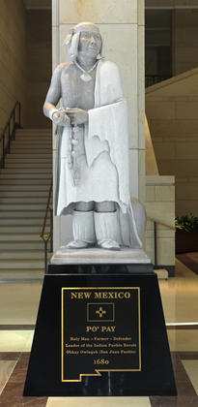
In 1680 the people known collectively as “Pueblos” rebelled against their Spanish overlords in the American Southwest. Spaniards had dominated them, their lives, their land, and their souls for eight decades. The Spanish had established and maintained their rule with terror, beginning with Juan de Oñate’s invasion in 1598. When the people of Acoma resisted, Oñate ordered that one leg be chopped from every man over fifteen and the rest of the population be enslaved, setting a pattern that lasted four-score years. Now, rising virtually as one, the Pueblos drove out Spanish soldiers and authorities. The rebels allowed many Spaniards to flee, but twenty-one Franciscan priests died at their hands, and they sacked mission churches across their land. It took twelve years for Spanish troops to reconquer Pueblo country. They never did conquer the Hopi, who had been the westernmost contributors to the rebellion.

Three hundred and thirty years later, Pueblo people still live in ancient villages across the Southwest, in many ways on their own terms. A proud statue of the rebellion’s leader, Popé (or Po’pay), is one of New Mexico’s two pieces in the National Statuary Hall in the United States Capitol. The Pueblo Revolt was the greatest and most successful rebellion of its sort in North American history. What happened? What did it signify? What did it achieve?

Unquestionably, one of revolt’s dimensions was religious. From Pecos Pueblo near the edge of the Great Plains to Acoma and Zuni in western New Mexico, Pueblo people had had enough of Christianity, after eight decades of living in what historian Ramón Gutiérrez has described as an imposed theocratic utopia. Backed by armed force and not reluctant to use the whip, Catholic missionaries had set out to destroy the ancestral Pueblo world in every respect, including what people could believe and how they could marry, work, live their lives, and pray. When the rebels could capture Franciscan priests, they killed them, sometimes after torturing them. They destroyed Catholic images, tore down mission churches, and defiled the vessels of the Catholic Mass. They put an end to marriages on Christian terms. They restored the kivas where Pueblo men had honored their ancestral Kachinas. With Catholic symbols and Spanish practices gone, the Pueblos set out to restore the lives their ancestors had lived.

Po’pay’s great achievement was to coordinate the Pueblos. The enormous, open distances of the Southwest posed a major problem. He solved it by dispatching runners carrying knotted ropes, each separate knot to be untied, one day at a time, until the chosen day, August 11, 1680. The runners had to deal with language differences as well. There was no distinct “Pueblo” people, speaking one language and sharing one culture. Instead, the Spanish conquerors had found Keres, Tompiros, Tewas, Tiwas, Towas, Piros, and Zuni, all living in similar-looking adobe villages (pueblos, hence the name), as well as Utes, Navajos, and Apaches. Their languages differed greatly, and their relations with one another were not always friendly. Nonetheless, Po’pay’s plan worked nearly perfectly. The Spanish rulers in Santa Fe received only the barest warning before the revolt broke out.

Despite the differences, as the late historian Jack D. Forbes demonstrated decades ago, the Southwest’s people were not strangers to one another at all. Neither distance nor language formed a barrier against communication. People in their settled adobe villages had had centuries to build relationships and customs, of commerce, alliance, peace, and war. By the time the Spaniards arrived, the settled tribes had also built relationships and customs with nomadic groups (the Utes, Navajos, and Apaches), creating webs of trade and understanding. In this regard Pueblo people were not much different from other settled horticultural villagers, including the Caddo of East Texas, the Mandan of the Upper Missouri Valley, and the Huron on Georgian Bay, all of whom also dealt regularly with nomadic neighbors. Pueblo languages differed, but so did Basque, Castilian, Catalan, Portuguese, and other tongues of the Iberian Peninsula. If a conflict led to war, village people knew how to abandon their permanent sites and find refuge among wanderers. If anything, the Spanish invasion intensified Native connections with one another. They learned about horses, mules, burros, cattle, sheep, and Spanish tools and weapons. Pueblo people had not worked out anything like the Great League of Peace and Power that the Iroquois developed about the time of Columbus to solve their own problems and that served them well throughout the colonial period. But the Pueblos and their neighbors possessed many ways other than warfare for dealing with one another.

The 1680 uprising was no isolated event. The seventeenth-century history of modern New Mexico and northern Mexico is punctuated by unrest and rebellion. Many of the region’s people had been conquered and none liked their situation, but they understood that though they greatly outnumbered the Spaniards, their foes were ruthless, organized, and determined. The Spanish possessed firearms and steel weapons superior to anything the Natives could muster. But despite all the odds against successful resistance, Spanish records show instance upon instance of plans and outbreaks among American Indians who supposedly had been “reduced” to Christianity and Spanish ways.

Other Native people besides the Pueblos took part in the revolt. Neighboring Apaches and Navajos remained free of Spanish dominion, both because of their nomadic way of life and because Spanish power had reached its limits. But for decades such people had had to deal with frontier warfare. Forbes suggested that “Pueblo Revolt” is actually a misnomer, and that the term “Great Southwestern Revolt,” reaching beyond Pueblo country, describes the late seventeenth-century events more accurately.

Without question Po’pay and his associates knew of the successful Pueblo resistance to the initial Spanish contact in 1540. They had reason to know about other Native resistance to Spaniards as well. They probably did not know about the ongoing seventeenth-century Iroquois-French conflict in the St. Lawrence Valley and eastern Great Lakes region, King Philip’s War in New England in 1675–1676, or Bacon’s Rebellion in Virginia, also in 1676. But, like the near-simultaneous founding of Spanish Santa Fe (1598), English Jamestown (1607), and French Quebec (1608), the Pueblo Revolt and the woodland wars emerged from similar situations. By the late seventeenth century, Native peoples and the Europeans they faced were not strangers to one another, whether we look at Pueblo country, Texas, the Mississippi Valley, the Great Lakes, or the Eastern woodlands. All were caught up in violent reverberations, as their worlds collided, ground against one another, and interlocked.

Slavery, rather than symbolic religious conflict, may have provided the deep underpinning of the southwestern events. Legal enslavement of American Indians by Spaniards had been forbidden by royal decree since the mid-sixteenth century, but that did not stop the actual practice. So-called “just wars” provided one loophole, and on that basis Apaches, Utes, and others who refused to acknowledge Spanish authority were fair game for enslavers. Settled Christian Indians, such as the Pueblos, could be enslaved for a period of time, if they resisted their condition. Forced encomienda labor, supposedly rendered in return for the benefits the Spaniards had brought, was not far from actual slavery. Enslaved Indians often ended up in the booming, labor-hungry silver mines of Chihuahua, but some were taken farther south and a few as far as Cuba, to work side by side with captured Africans. A lively traffic flourished across the plains in Native women and children, for both sexual exploitation and domestic labor.
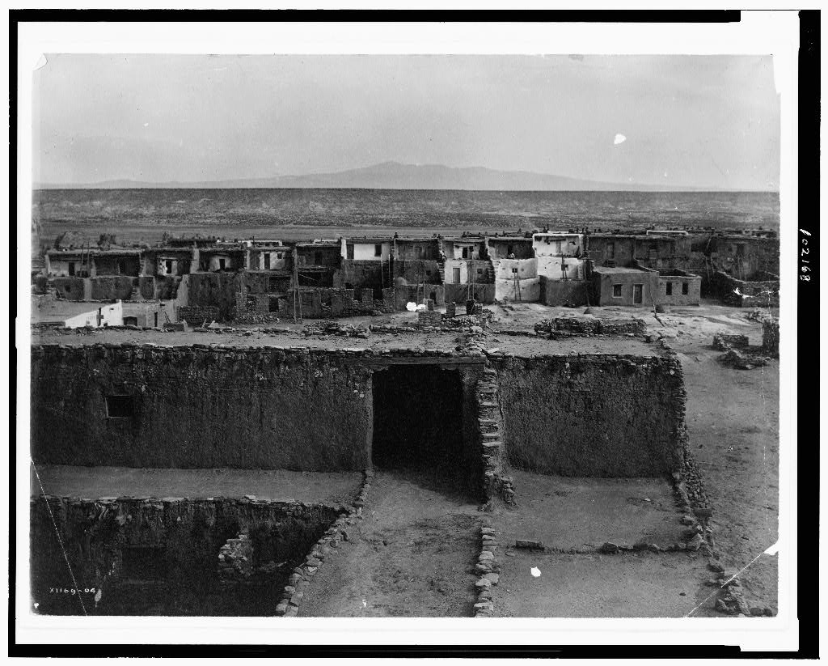

Acoma Settlement, photographed from church top.

Jemez Pueblo Indian Ceremonial Dance, New Mexico

Biography of Popé:

A religious leader from San Juan Pueblo in present-day New Mexico, Popé organized and led the most successful Indian uprising in the history of the American West.
Very little is known of Popé's life. He was apparently a native of San Juan Pueblo, but moved to the nearby pueblo of Taos in the 1670's. Provoked by a Spanish crackdown on native religious practices in 1675, Popé soon began conferring with other disaffected Pueblo leaders, some Apache with ties to the Pueblos, and nearby villages, about the possibility of large-scale revolt against the Spanish. He offered a millenarian vision to the Pueblos, stressing the complete expulsion of Spanish military and religious authority, the elimination of Christian and Spanish cultural practices, and the return of Pueblo deities. Despite his cultural militance, Popé seems to have been deeply influenced by Christian cosmology, for his emphasis on the return of three Pueblo deities bears a striking resemblance to the Christian trinity.
Popé launched his revolt early in August 1680. He achieved stunning success, due to the Pueblos' vastly superior numbers -- more than 8,000 warriors against fewer than 200 arms-bearing colonists -- and to the high degree of coordination he had achieved. Despite language differences and distance, the Pueblos attacked everywhere at once, killing 21 Franciscan friars and more than 400 Spanish colonists. Those Spanish who survived this initial onslaught fled to the Governor's Palace in Santa Fe, where Popé's warriors surrounded them. In late August, they made a desperate attempt to break the Indians' siege and were lucky to escape to El Paso.
Having driven the Spanish from New Mexico, Popé tried to eradicate every possible vestige of their culture. He ordered the destruction of Christian objects and churches, punished the speaking of Spanish and the use of Spanish surnames, and argued against using Spanish tools such as the plow. In his style of leadership and exercise of personal power, however, Popé seems to have retained an element of Spanish authoritarianism which alienated many and contributed to the breakup of the Pueblo alliance.
Less than a year after Popé's death in 1692, troops under Diego de Vargas reconquered New Mexico for Spain. But reconquest did not mean a return to the days before the uprising. Popé's revolt had permanently weakened the political power of the Franciscans, whose missionary efforts had been the focus of Spanish interest in the region. Now Spain was more interested in New Mexico as a barrier between the French and Mexico's northern provinces. Accordingly, the Pueblos were now given greater latitude for their own religious practices, and fewer demands for food and labor were placed upon them. The Spanish even armed the Pueblos to defend their own villages and acknowledged their rightful ownership of village lands. In short, the post-rebellion political system in New Mexico can be seen as a Pueblo-Spanish alliance, particularly in respect to their common enemies, the Apache, Navajo, Ute and Comanche raiders.
Given his nativistic radicalism, Popé could never have welcomed such an alliance between the Pueblos and the Spanish, yet by making this alliance possible, he created the conditions for a new culture to emerge in the American Southwest, a blend of Indian and European influences which retains its distinctive character even today.

