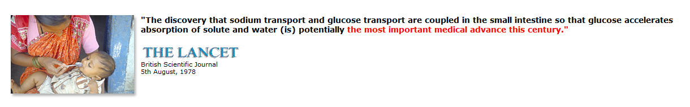
Oral Rehydration Therapy: How it Works
Author: Roger M. Goodall
We are often asked to explain how ORT works - a question that can only be answered successfully by first considering some of the simple physiology of the normal intestine and then the changes that occur in a state of diarrheal disease.

THE PHYSIOLOGICAL PROCESS
In the normal healthy intestine, there is a continuous exchange of water through the intestinal wall - up to 20 liters of water is secreted and very nearly as much is reabsorbed every 24 hours. This mechanism allows the absorption into the bloodstream of soluble nutrients from digested food.
Typical values for the daily gains and losses of water in an average man in a temperate (not too warm or humid) climate are:

Intake | Volume  ml per day | Output | Volume  ml per day
Drink | 1300 | Urine | 1500
Food | 850 | Expired Air | 400
Metabolic Water | 350 | Skin | 500
 |  | Feces | 100
Total | 2500 | Total | 2500

In a state of diarrheal disease the balance is upset and much more water leaves the body than is reabsorbed, causing a net loss to the body which can be as high as several liters a day. In addition to water, sodium is also lost. The body's store of sodium (in the form of sodium ions Na+) is almost entirely in solution in body fluids and blood plasma (outside the cells). By contrast 98% of the body's total potassium (K+) is held within cells, i.e. intracellular.
Approximate concentrations of the principal ions in plasma (blood), interstitial (surrounding the cells), and intracellular fluids in an average man are:
 | Plasma | Interstitial  fluid | Intracellular  fluid
Cations (mol per liter)
Sodium | .140 | .144 | .010
Potassium | .004 | .004 | .155
Calcium | .0025 | .002 | .001
Anions (mol per liter)
Chloride | .102 | .114 | .005
Phosphate | .001 | .001 | .050
Sulfate | 0.0005 | 0.0005 | 0.01

(**both plasma and interstitial fluids are part of the “extracellular” fluid**)
The concentration of Na+ in the extracellular fluid has to be held to within close limits (0.135-0.150 mol/L) for the proper functioning of the body. Normally, this sodium concentration is precisely controlled by the kidneys. However in a state of dehydration water is conserved by anuria (lack of urinating) and the sodium regulation cannot work effectively. Thus, continued diarrhea causes rapid depletion of water and sodium, which is to say, a state of dehydration. If more than 10% of the body's fluid is lost death occurs.
The approximate distribution of body water in an average man is:
Compartment | Volume  liters | % of total  body water
Total body water | 42 | 100
Extracellular | 17 | 40
Plasma | 3.2 | 7.6
Interstitial | 12.8 | 30
Transcellular | 1 | 2.4
Intracellular | 25 | 60

Simply giving a saline solution (water plus Na+) by mouth has no beneficial effect because the normal mechanism by which Na+ is absorbed by the healthy intestinal wall is impaired in the diarrheal state and if the Na+ is not absorbed neither can the water be absorbed. In fact, excess Na+ in the inside of the intestine causes increased water loss and the diarrhea worsens.
If glucose is added to a saline solution a new mechanism comes into play. The glucose molecules are absorbed through the intestinal wall - unaffected by the diarrheal disease state - and in conjunction sodium is carried through by a co-transport coupling mechanism. This occurs in an approximate 1:1 ratio, one molecule of glucose co-transporting one sodium ion (Na+).
It was the discovery of this mechanism of co-transport of sodium and glucose that allowed for the practical application of ORT for instances of diarrhea or other extreme sickness.
It should be noted that glucose does not co-transport water - rather it is the now increased relative concentration of Na+ across the intestinal wall which pulls water through after it—water moves by simple diffusion/osmosis so as to have both sides of the membrane at equilibrium.
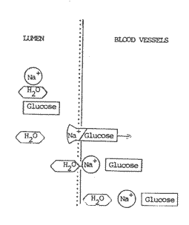

GLOSSARY OF SOME OF THE TERMS USED
ION (ELECTROLYTE)
A single electrically charged particle into which the atoms or molecules of some substances dissociate (dissolve) when in solution. For example, solid sodium chloride contains atoms of sodium (Na) and atoms of chlorine (Cl) bound together. When dissolved in water, the molecule splits into two ions (Na+) and (Cl-) each of which tends to be loosely bound to three or four molecules of water.
Positively charged ions (e.g. Na+) are called CATIONS and negatively charged ions (e.g. Cl-) are called ANIONS.
SOLUTE
A dissolved substance. E.g., sodium chloride (the solute) dissolves in water (the solvent) to give a solution.
MOLARITY
The number of moles of solute in a given volume of solution.
HYPERNATRAEMIA
The presence of an excess amount of sodium Na⁺ in the blood plasma (Normal Na⁺ concentration is 0.140 mol/L.)

NORMONATRAEMIC - the presence of a normal level of sodium in the blood plasma

HYPONATRAEMIC - lower than normal sodium level in the plasma.

